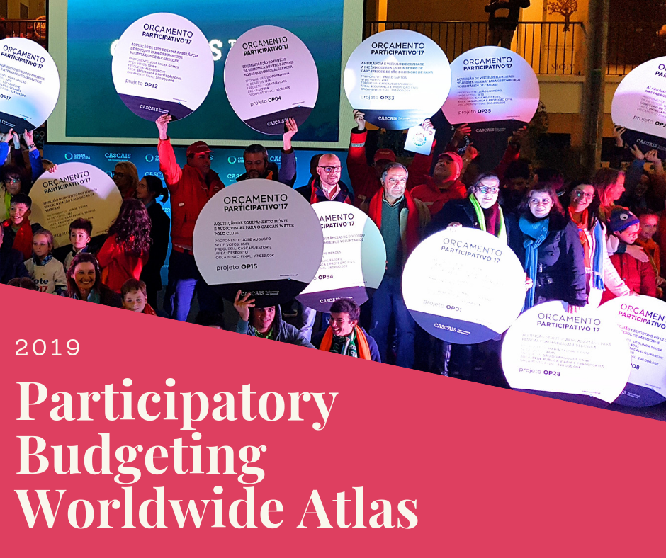

Coordination
Nelson Dias e Sahsil Enríquez

More information
www.oficina.org.pt/atlas.htlm

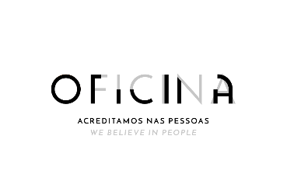

PRESTENTATION
The collaborative work that took place while preparing the second edition of “Hope for Democracy”, revised in 2018, exposed the massive dissemination of Participatory Budgeting Worldwide. The numbers associated with those initiatives are largely significant face to what was earlier expected by the most informed experts on this issue.
Collected data allowed to identify three macro trends seen in the last years, as synthesized in the mentioned book, namely:
- The role of central Europe, being nowadays the continent with the higher number of processes;
- Increase of the territorial and institutional scale of PB, with the reinforcement of regional and national initiatives;
- Strengthening of the institutionalization of PB in some countries, which is partly responsible for the increase in registered cases.

This work leads to the idea of creating a Participatory Budgeting Worldwide Atlas, of a desirable annual edition of public access nature, that can be used as a source of information for all actors who are interested in the matter. Nevertheless, due the geographical diversification and the lack of monitoring systems of PB experiences, the Atlas represents an effort to get an insight of the current situation, that will be only possible if the project it’s founded on a networking and collaborative model between the different actors willing to participate.

The Participatory Budgeting Worldwide Atlas is an annual publication build by:
(i) A set of maps displaying the territorial distribution of the processes;
(ii) A bookmark with individual files containing information from each country;
(iii) A block of texts produced by experts, that includes the main trends registered in the world.

TEAM
The Atlas should be based on the following collaborative structure:
- A Global Coordination responsible for managing the production of the Atlas, establish a liaise among the different actors involved in the project, organized all the collected data, analyze the main trends and redact synthesis about them, as well as editing the Atlas and making it available to the public;
- A Scientific Council, composed by experts on the matter, whose primary function is to advise the Coordination. Also, to identify partners/colleagues in other countries in order to invite them to collaborate in the analysis of the main trends registered and finally to compose the synthesis;
- A Network of Local and Regional Interlocutors, partially integrated by the authors of the book “Hope for Democracy”, as well as others that can be identified during the production of the Atlas.
The coordination effort, as well as scientific counseling and data collection executed by the actors implicated is entirely voluntary. The funding obtained with the support of the City Council of Cascais in Portugal, will be used exclusively to compensate the costs of editing and printing of graphics.

METHODOLOGY
A questionnaire will be use as a common tool in order to simplify and homogenize the collection of data from local and regional interlocutors.
This instrument will be made up by a series of standard questions to facilitate its filling. The application of the questionnaire will be voluntary and should take place in a context of large regional differences. Hence, it will allow to acquire solid and detail information about the processes, but in some other cases the material about the Participatory Budgeting will be imitated.
It is the duty of both the person in charge of apply the questionnaire and the informant to ensure its completion and to make available the outcomes to the Coordination so the creation of the Atlas can take place.

STRUCTURE
The Atlas should contain three primarily elements:
- A worldwide map with geographical and numerical references regarding the Participatory Budgeting, as it’s shown in the book “Hope for Democracy”;
- An analytical synthesis of the Atlas that includes information about the main registered trends;
- Documentation collected by the interlocutors about different countries comprised in the Atlas.
All this information will be display as a digital format, but also as limited edition printed book, which will be publicly presented during the “Smart Citizenship Academy” event that will take place in Cascais, Portugal.

CONTACT
Atlas coordinator’s contact information:
Nelson Dias e Sahsil Enríquez
Email atlas@oficina.org.pt

FILLING INSTRUCTIONS
Participatory Budgeting processes are known for their large methodological flexibility, which makes it difficult to well define a single and consensual concept that applies to all initiatives.
Therefore, for the purposes of this research and for an adequate filling of the questionnaire, it’s necessary to establish a common understanding on what a Participatory Budgeting is. Thereby, the gathered data will provide a more concrete and effective approach of the complex reality of these experiences around the world.
Being that said, it’s proposed that the Participatory Budgeting experiences hold the following characteristics:
- It must be a process that involves a specific portion or the entire amount of an institution’s budget, so that can be freely and independent decided for all the citizens participating in the project. This feature comprises two more items:
I.1) The type of the institution. Despite, the fact that an overwhelming number of initiatives are promoted by the local government, it’s important to take into consideration those experiences organized by other levels of government such as: regional, state and national. Also, processes developed by private, lucrative and associative organizations should be included.
I.2). The participants. There are different models. The most common is the universal access, which is open to individuals of a certain territory or institution. However, those processes aimed at more specific audiences will also be taken into account, such as initiatives addressed to a particular social sector like young people, women, immigrants, etc.; or at a much more precise target as officials of an entity or company, partners of an association, among other options. Also, representative groups or lager communities (lottery system).
- The initiative must be organized in two successive cycles, focusing on the decision-making phase, in which the participants are able to make proposals and also the execution one regarding the period of time where the projects are implemented.

- It should be a continuous practice, meaning that the implementation of the project has to be periodic, taking place during a certain period of time.

- The results ought to be available to all actors involved in the process.

QUESTIONNAIRE
Attention: The information gathered through the following questionnaire is owned by the interlocutor responsible for its filling. The Atlas coordination team will be using this data purely for statistical and analytical purposes, always protecting the identity of the contributors.

Author
Indicate the name of the interlocutor or interlocutors responsible for providing the available information.

Country
Indicate the name of the country in regard to the collected data (For example: Brazil).

Total number of Participatory Budgeting processes.
Indicate the number of active Participatory Budgeting experiences. Take into consideration all the Participatory Budgeting projects regardless the differences among them. (For example: 235).

Participatory Budgeting experiences promoted by the local government.
Indicate the number of Participatory Budgeting promoted exclusively by local governments.

Participatory Budgeting initiatives promoted by regional, state and national governments
Indicate the number of Participatory Budgeting initiatives promoted exclusively by regional, state and national governments.

Participatory Budgeting processes promoted by other type of institutions
Indicate the number of Participatory Budgeting processes promoted exclusively by type of institutions (companies, associations, etc)

Participatory Budgeting projects developed in large cities
Indicate the number of Participatory Budgeting projects developed exclusively by cities with a population over than 1 million habitants. Also, indicate the name of the city or cities.

Number of Participatory Budgeting initiatives developed by capital cities.
Indicate the number of Participatory Budgeting initiatives developed exclusively by capital cities: state or national. Also, indicate the name of the city or cities.

Legislation regarding the regulation of Participatory Budgeting experiences
Indicate if there is or not or if it’s being developed a legislation regarding the regulation of Participatory Budgeting experiences. It can be on any type of level (local, city, regional, state or national).

Outstanding innovation
Name the main innovation in the Participatory Budgeting process in your country implemented on the year on course. (1500 characters maximum).

Principal tendencies detected
Indicate the principal tendencies detected during the implementation of Participatory Budgeting experiences in your country regarding the year on course, for example: the growth of digital practices, the insertion or reinforcement of children and young people into the practices, etc. (1500 characters maximum).

Other information
Insert additional information that you think it might be relevant for a better understanding of the Participatory Budgeting projects developed in your country (1000 characters maximum).

